|  |
| --- |
| College LaSalle |
| Project - Internet Programming User Manual |
|  |
| Presented to: Mihai Maftei |

|  |
| --- |
| Author:….Salomon Bulambo  11/28/2022 |

This is the folder which contain a login file just open it and Run the Index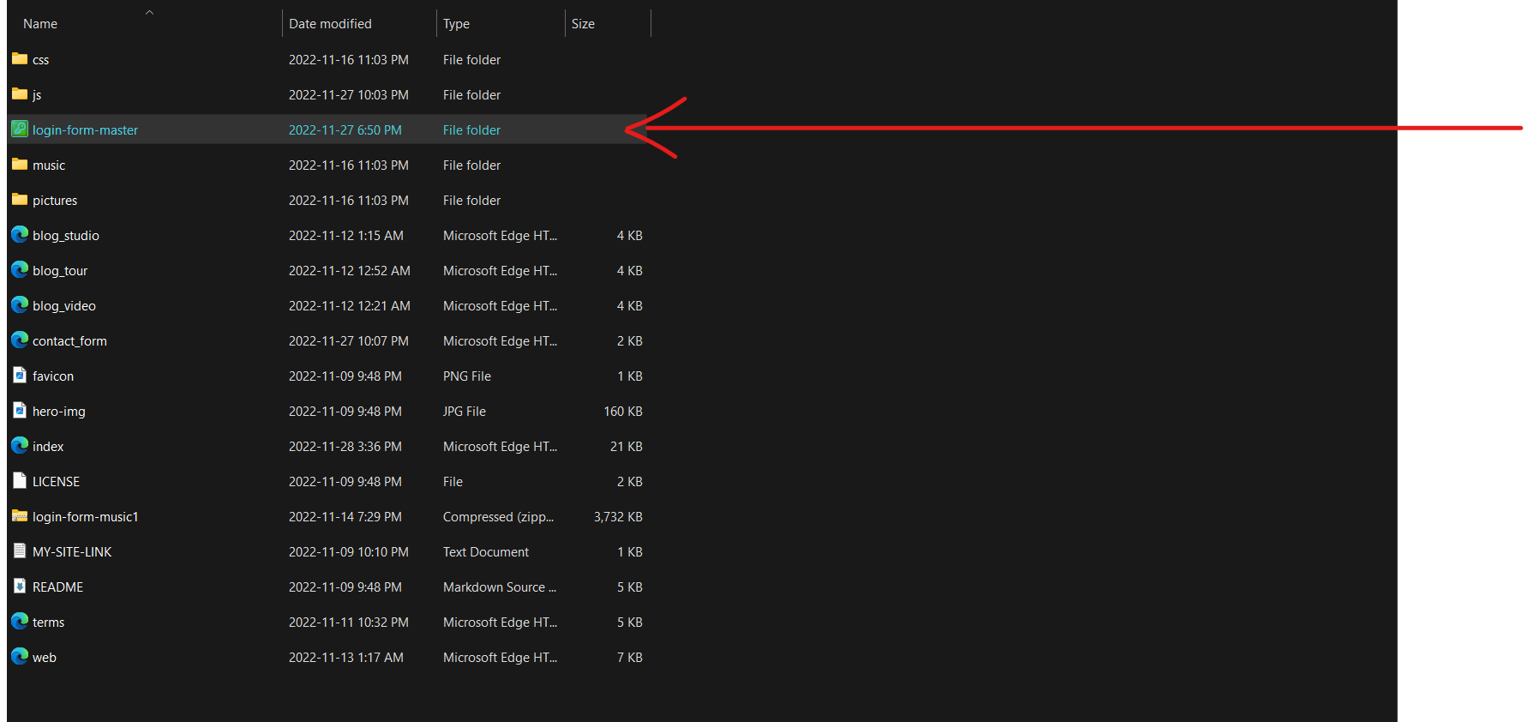

Enter personal information :

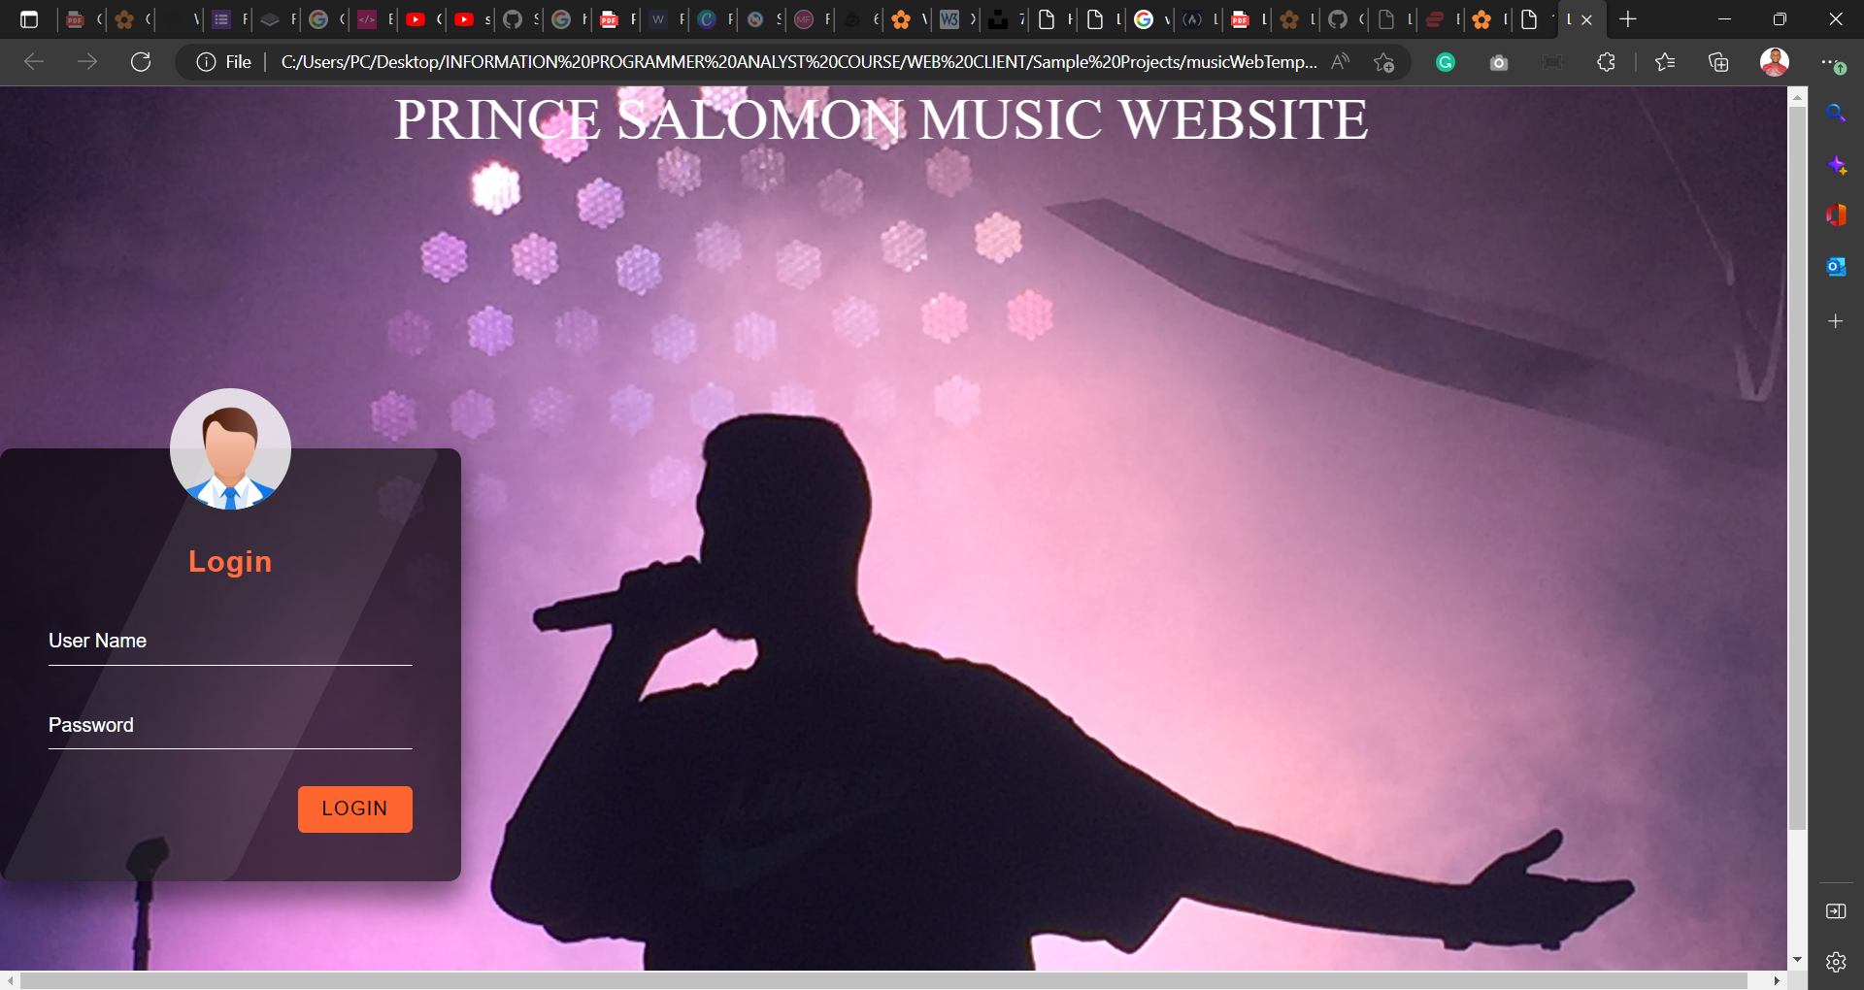

The logon page

Enter your Username and Password in order to enter to my web site. (**salomon@proj.ca**, **123**)

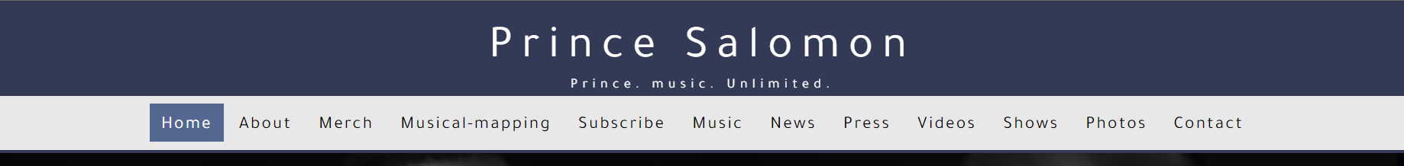

After login

1. This is my first page after the user login to the website, it is showing the menu which contains different pages on the website. Click on one of the links to have access to different applications.

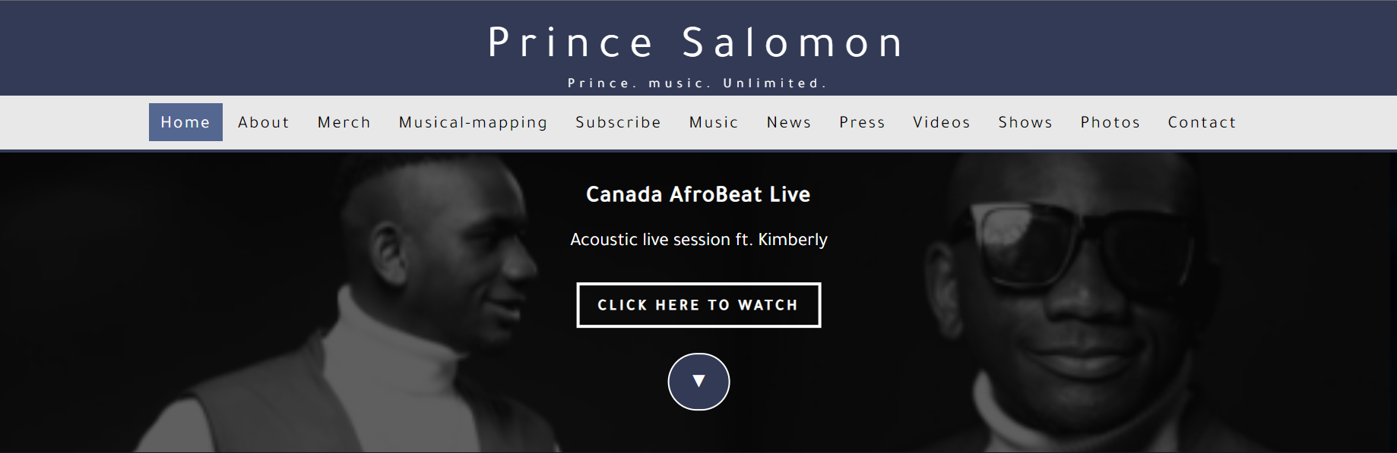

This is the Home page once you click on it displays the image in the background and some information about that image.

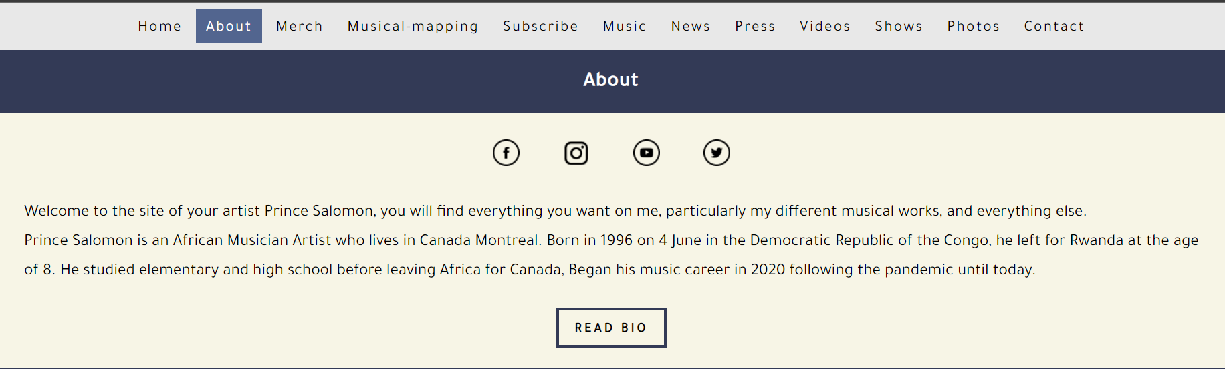

My About page is describing some information about the page the Artist, then if you want to see more regarding the Artist you click on READ BIO to keep reading.

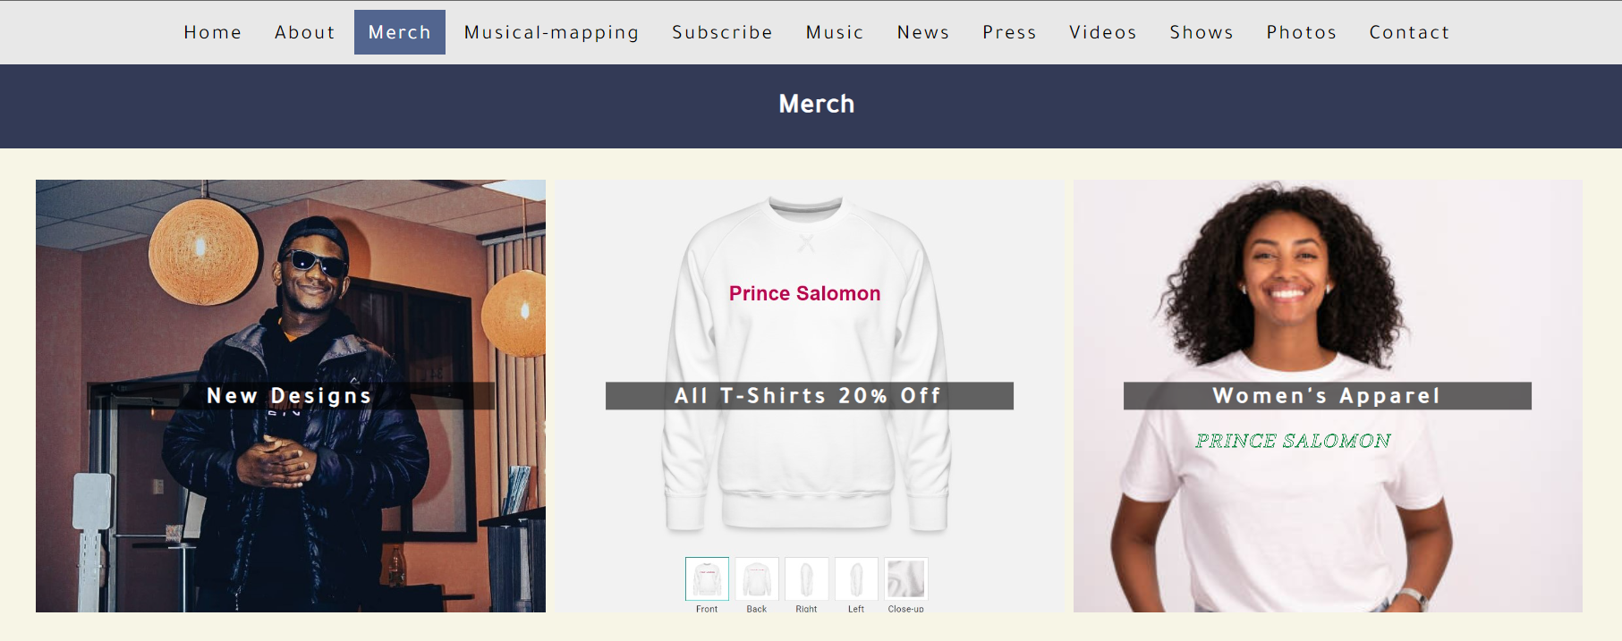

The Merch page is an exposition of the Artist product’s which is available to buy when you get interested

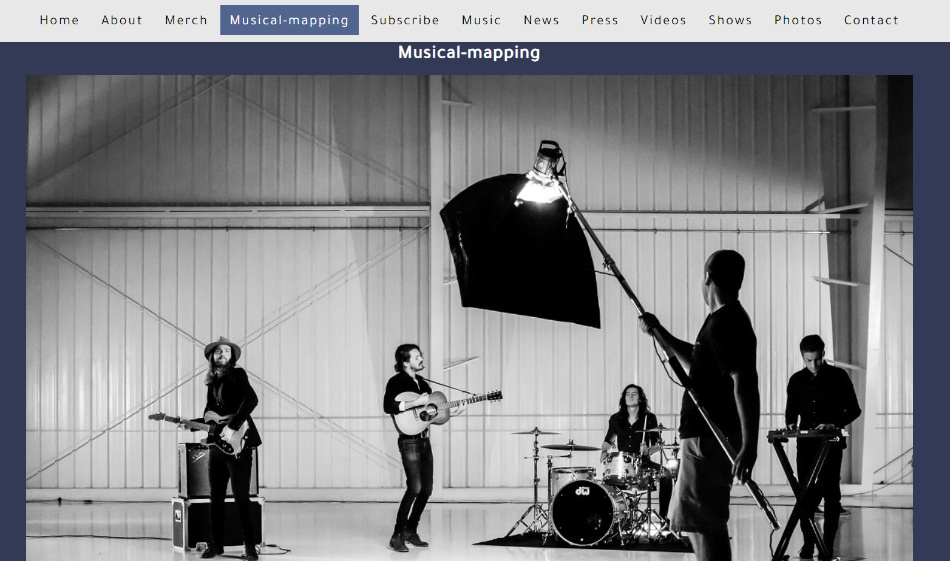

Musical mapping page is demonstrating an image that contains a music band in the studio doing a live recording, then if you click on any instrument it opens a new page that gives you more information about that instrument

**Musical mapping references link:**

**Solo Guitar:** https://www.google.com/url?sa=i&url=https%3A%2F%2Fwww.guitarhabits.com%2F50-of-the-greatest-guitar-solos-of-all-time%2F&psig=AOvVaw2Nivb3vvWNvh_DNogjaZOj&ust=1669694503589000&source=images&cd=vfe&ved=0CA0QjRxqFwoTCMiT-ff-z_sCFQAAAAAdAAAAABAD

**Video Lighting:** <https://www.google.com/url?sa=i&amp;url=https%3A%2F%2Ffiltergrade.com%2Flighting-set-ups-techniques-product-videos%2F&amp;psig=AOvVaw1JZcKVBT-ar5-iWZJAHBR3&amp;ust=1669696693342000&amp;source=images&amp;cd=vfe&amp;ved=0CA0QjRxqFwoTCOCwoZSH0PsCFQAAAAAdAAAAABAD>

**Acoustic Guitar:** <https://en.wikipedia.org/wiki/Acoustic_guitar>

**Mini Studio Piano MDI Controller**: <https://www.google.com/url?sa=i&amp;url=https%3A%2F%2Fmusictech.com%2Fguides%2Fbuyers-guide%2Fthe-best-keyboard-controllers-to-buy%2F&amp;psig=AOvVaw0sFBQacUfrNgXFQ6OE132H&amp;ust=1669697325354000&amp;source=images&amp;cd=vfe&amp;ved=0CAwQjRxqFwoTCOiMzrGJ0PsCFQAAAAAdAAAAABAE>

**Piano Stand:** https://cosmomusic.ca/product_images/behringer-ks1002/60d3cb06574a930018a01816/super_zoom.jpg?c=1624492806

**Guitar Amplifier:** <https://en.wikipedia.org/wiki/Guitar_amplifier>

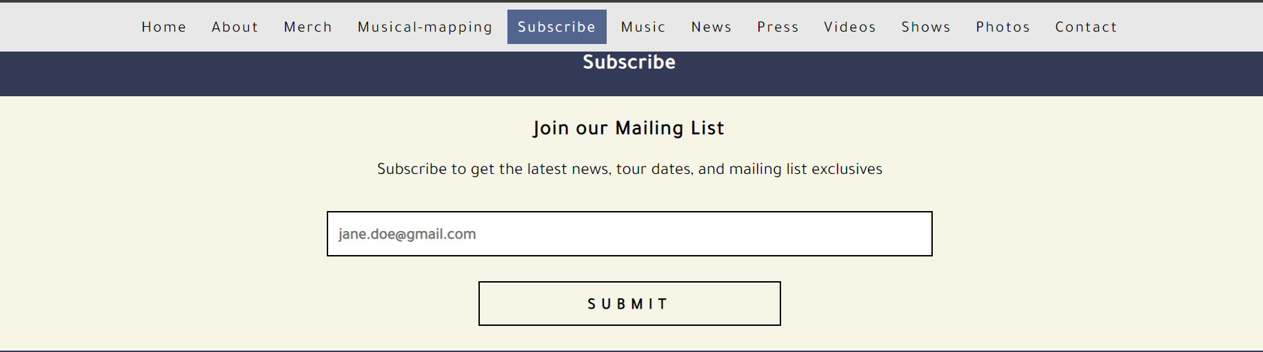

Subscribe page is giving you the option to enter your Email and submit so you will be able to receive the latest updates through Mail.

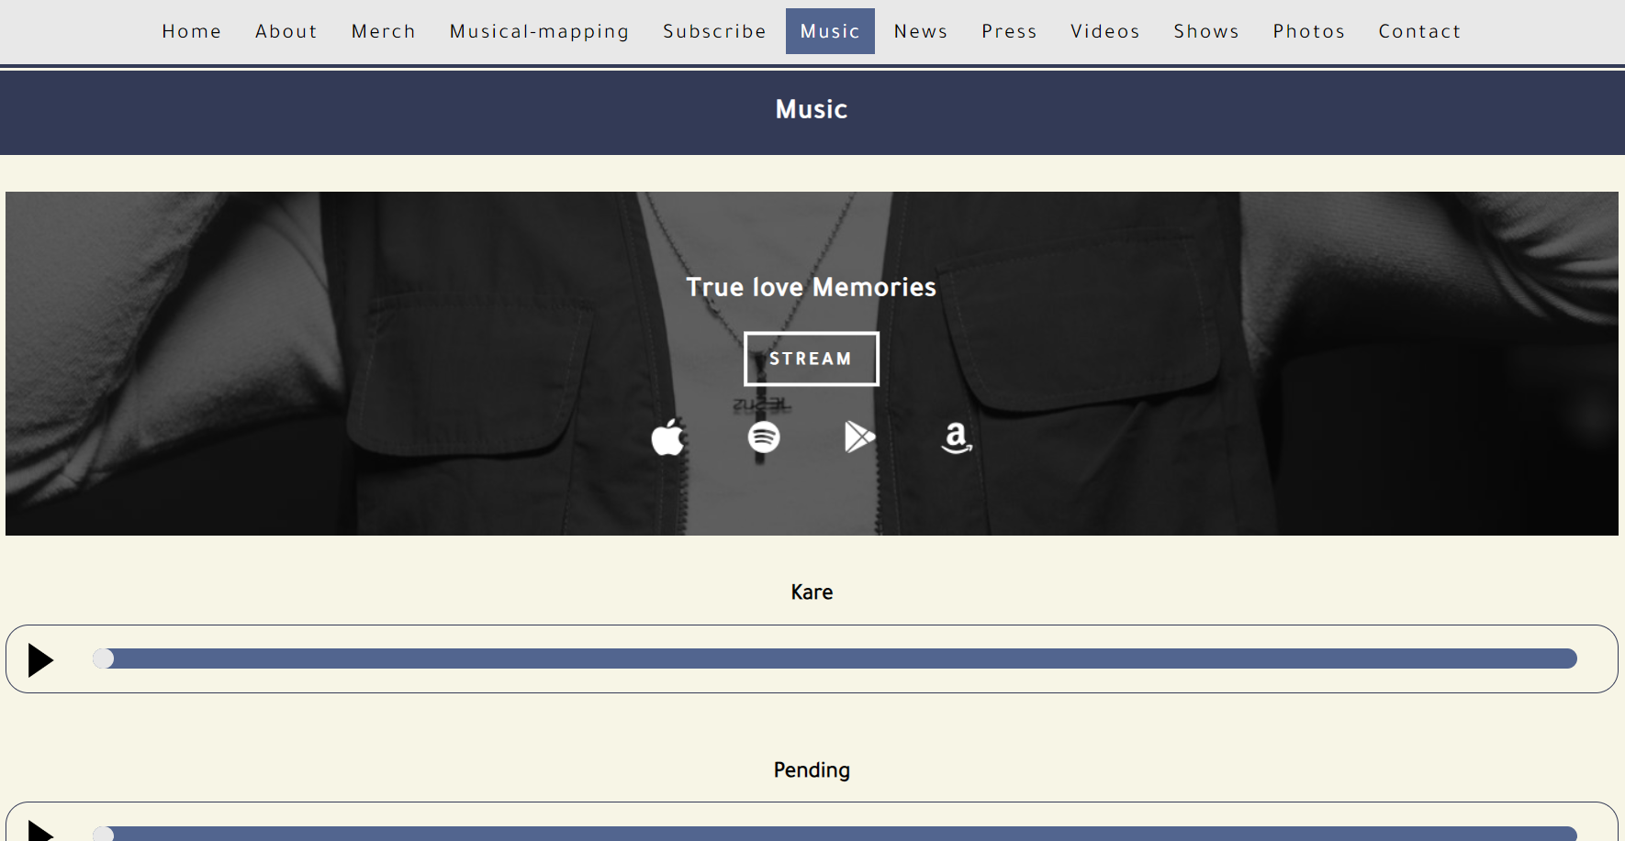

Music page presents Artist’s songs and Albums which are already been released, so you don’t need to go anywhere looking for his Audio music you can listen to them through this site

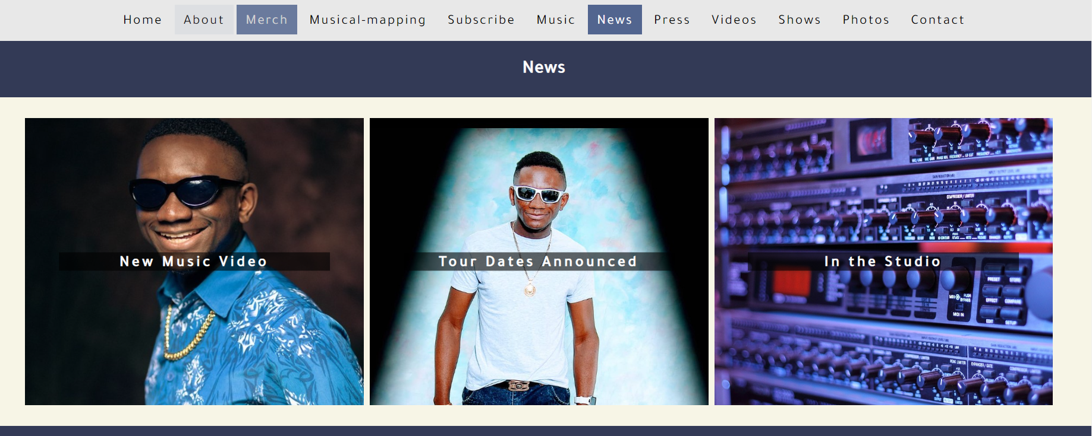

News page manifesting Artist’s latest news regarding his music, In the studio, Announcing new tours and new projects

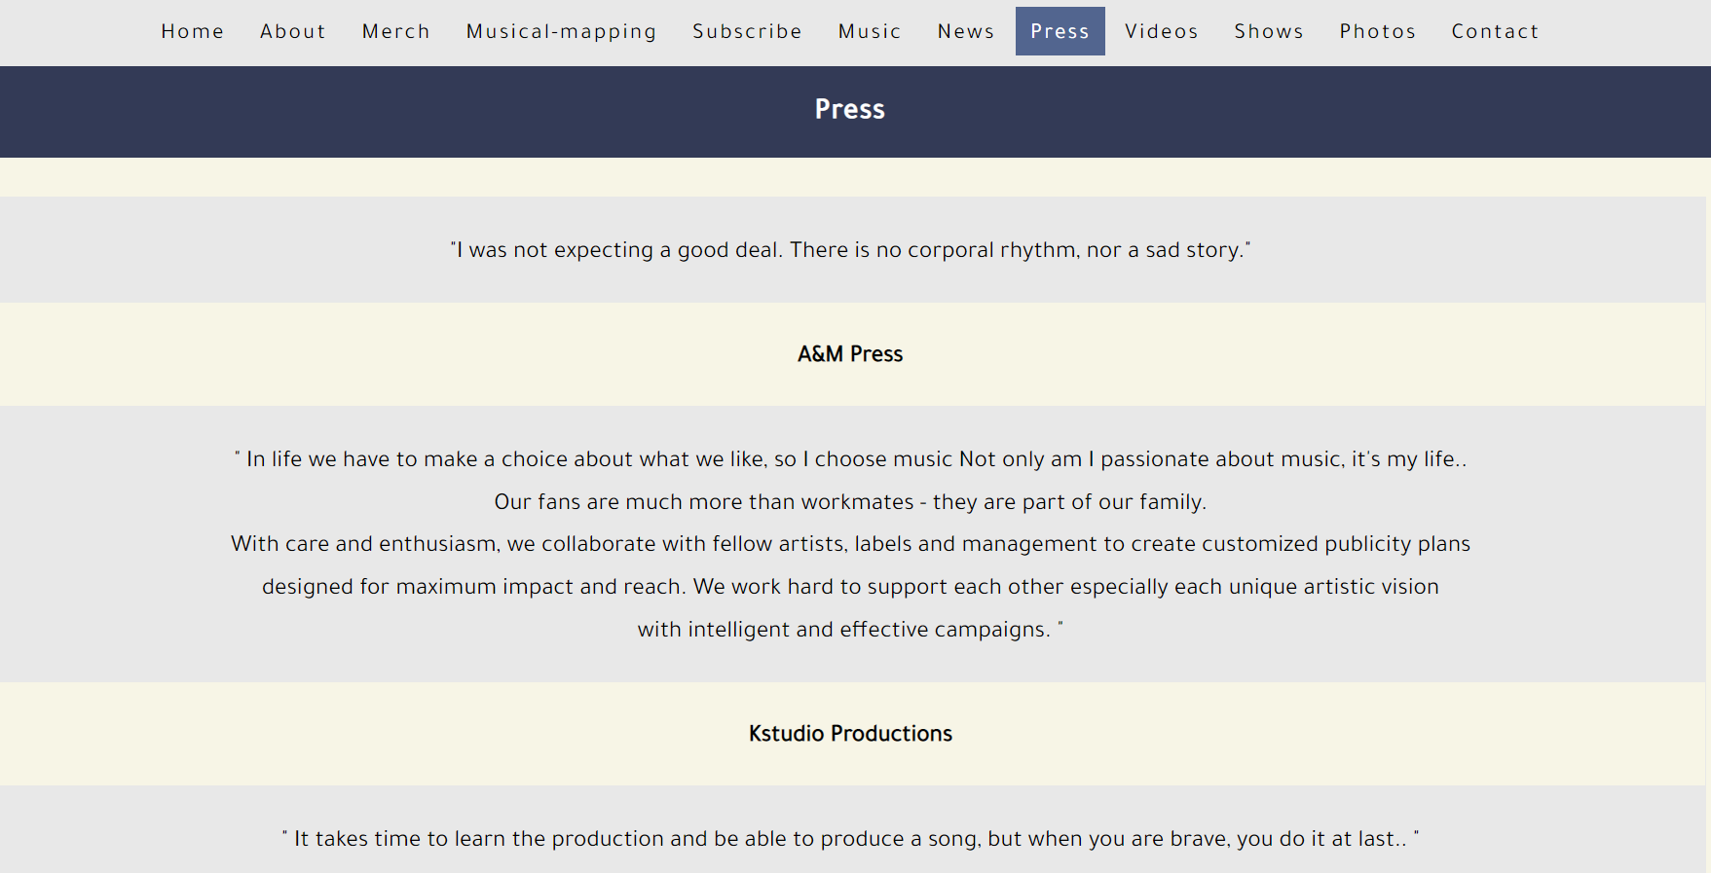

This Page is named Press and is all about the briefing of the Artists’ presentations on radio and Tv station, it shows Artist’s favorite word and Proverbs

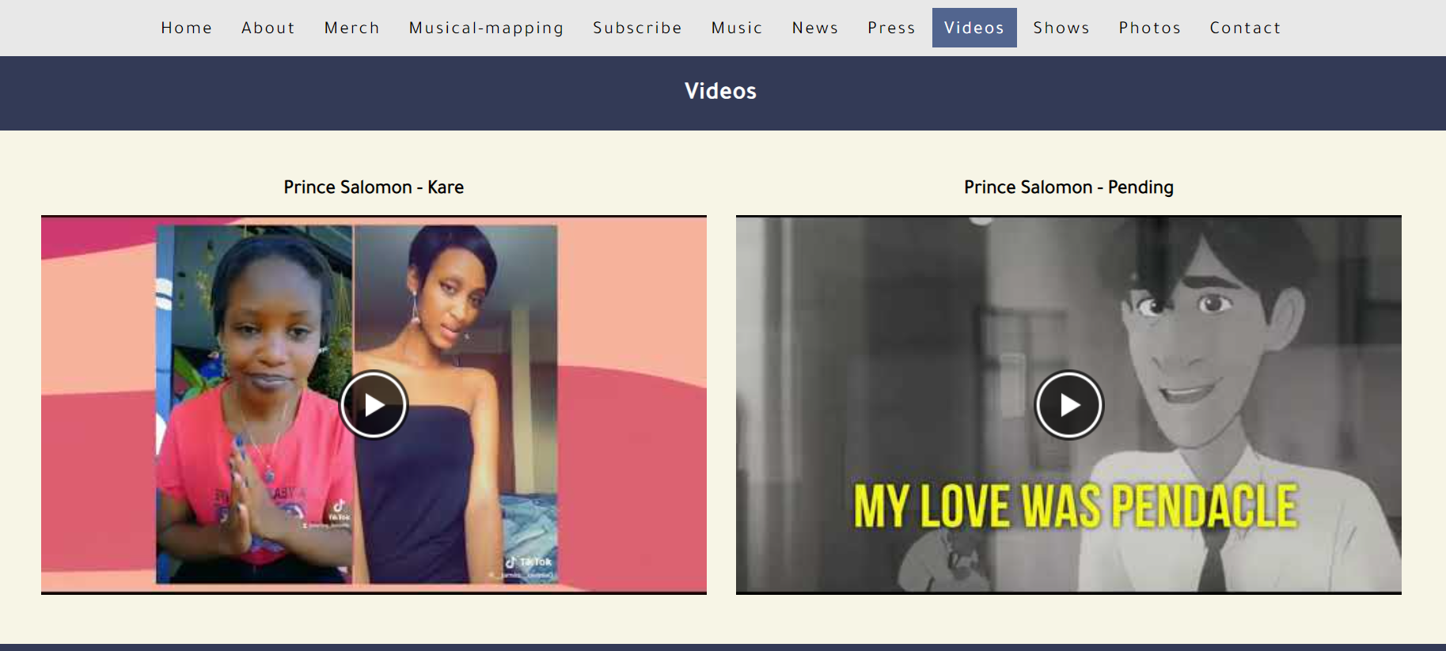

Video page is displayed Artist’s recent music videos through the site, so you can view them here and enjoy The videos

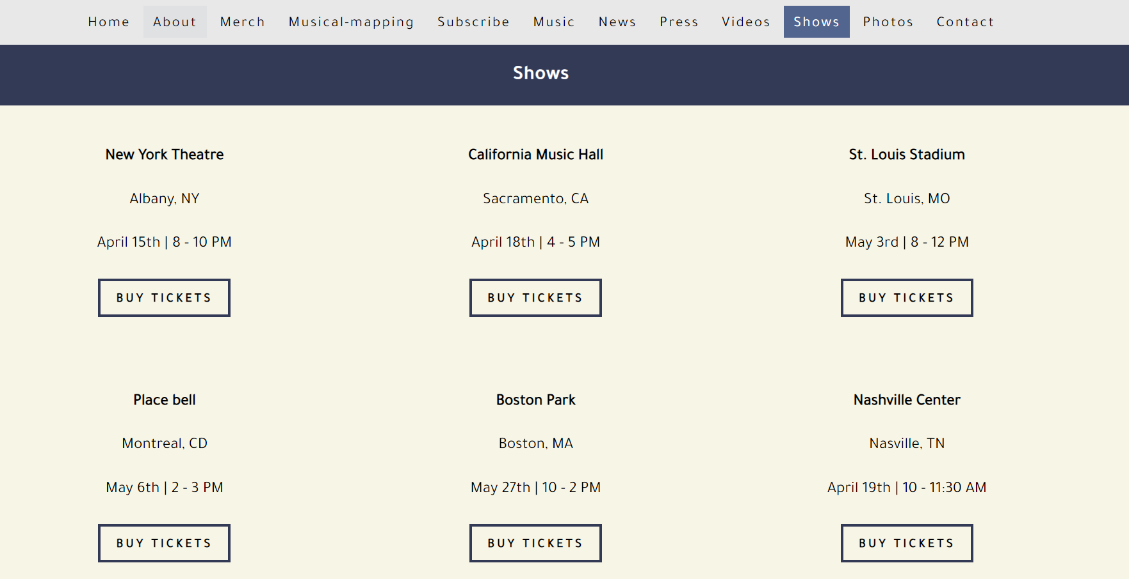

The Page Shows is presenting to you the Artist’s concert and all the events he will be appearing on

Then you can be able to buy Tickets before Sold out.

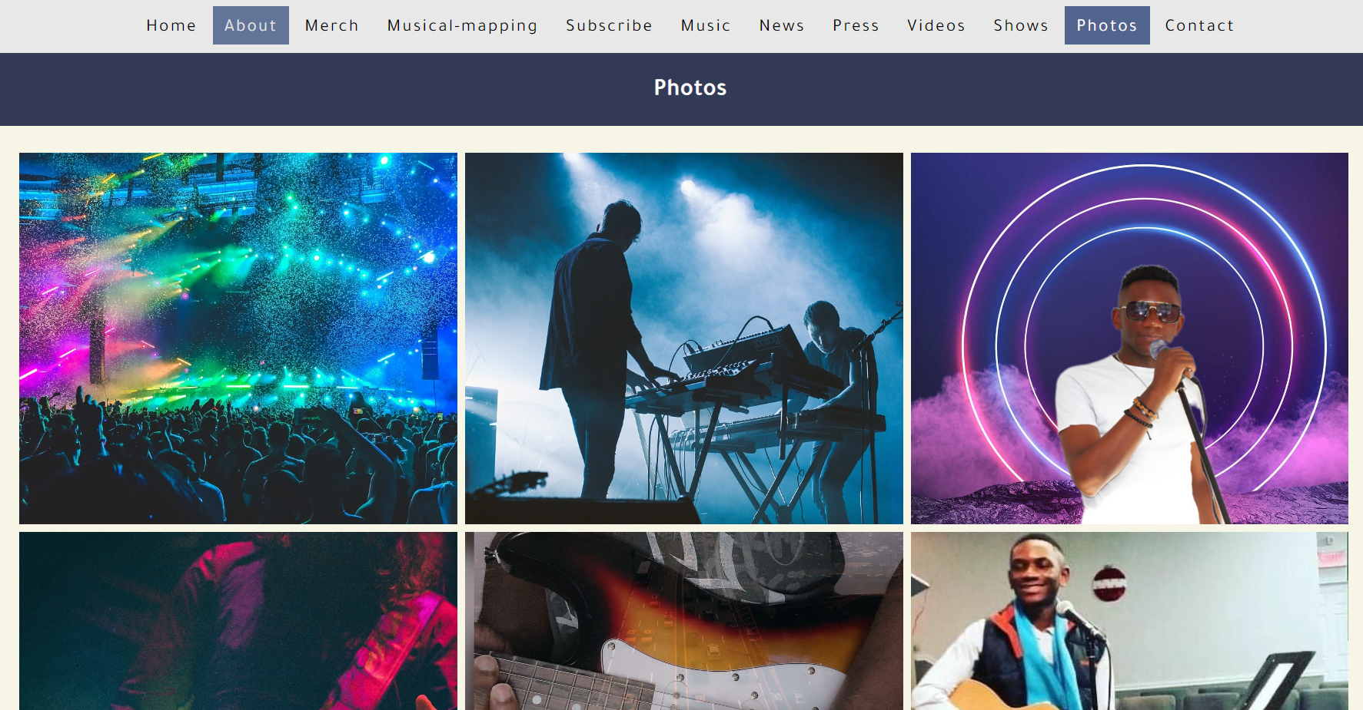

Photos page is demonstrating Artist’s pictures that were shot in Concerts and Public spectacles when he performed.

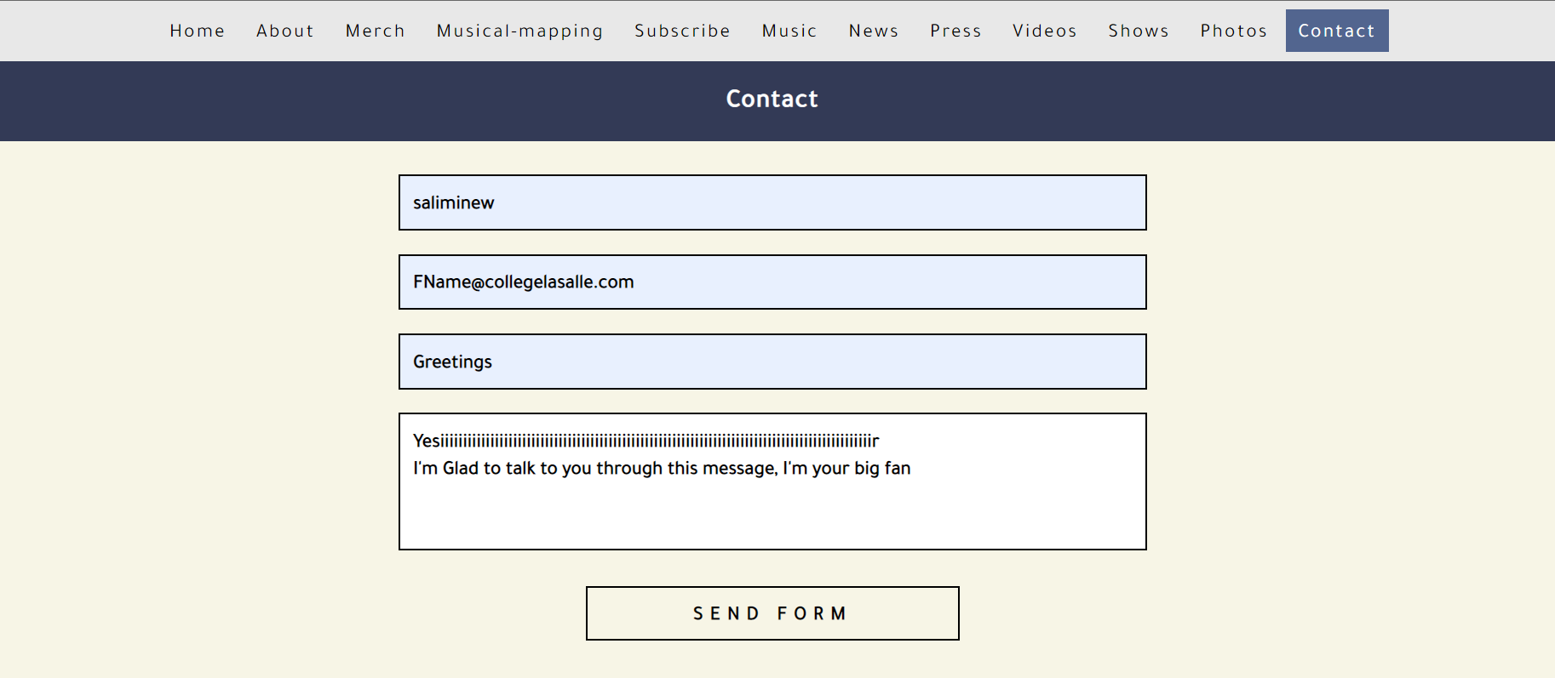

The contact page is a special page that gives you the ability to send a message to the Artist and wait for the feedback when he will answer your message.

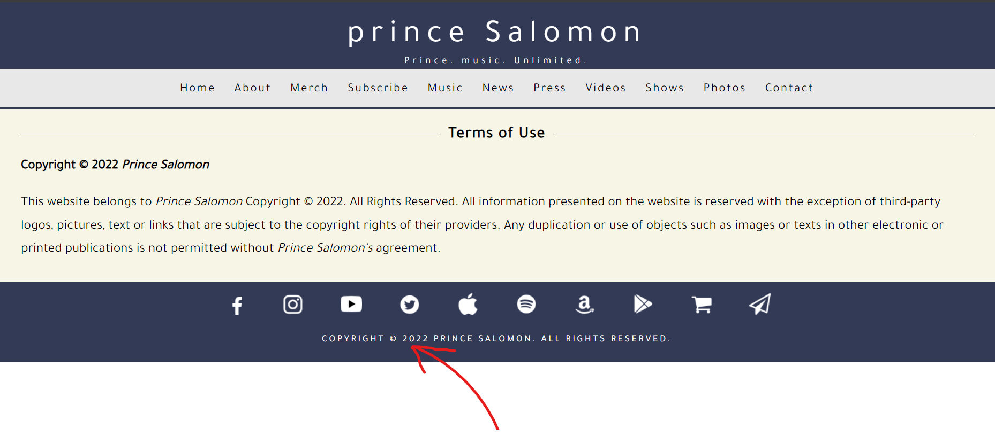

When you click on the Copyright page you can see the Terms and Condition of Use

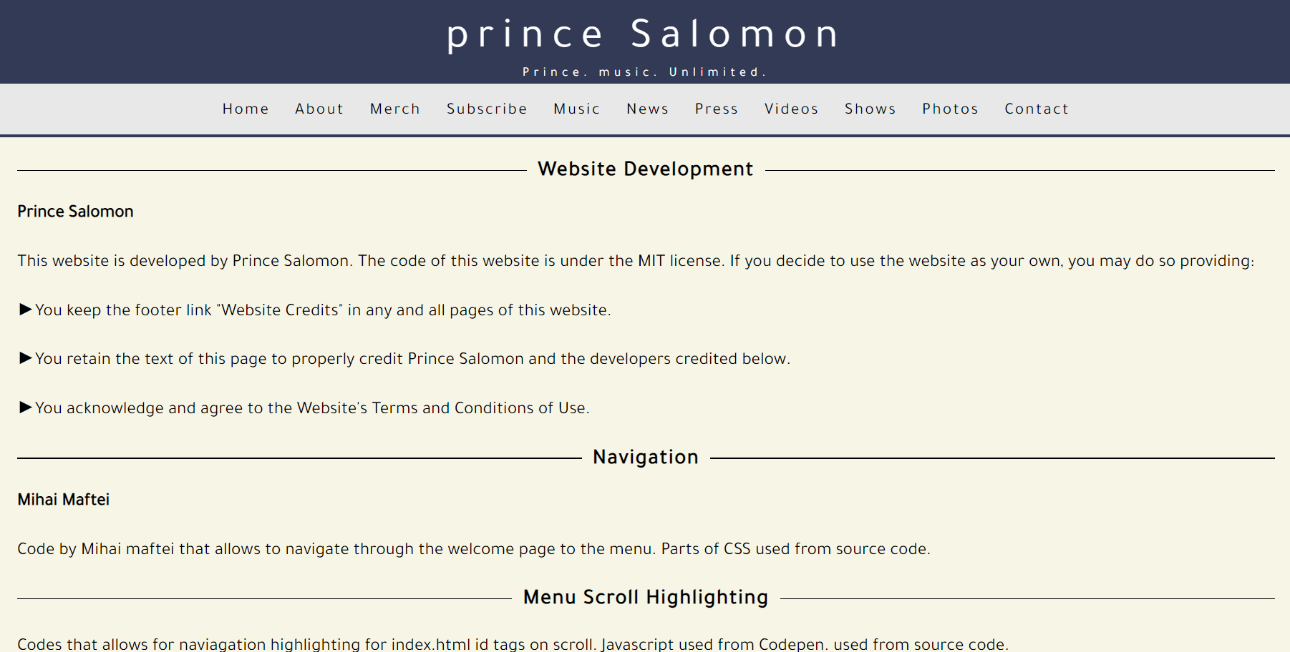

This Page is the last one it shows WEBSITE CREDITS it located down in bottom

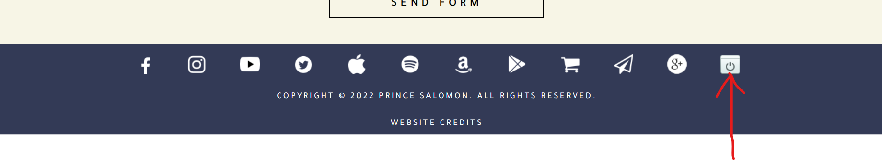

Before Logout

This Picture is showing a button the user must click to move to the Logout page

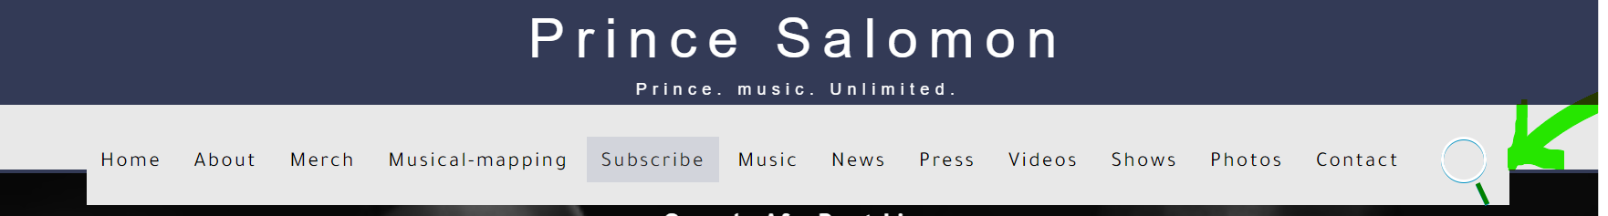

Search Bar

The Picture show the Taskbar that can be used by the user to search certain thing

Reference code

https://codepen.io/takaneichinose/pen/gKVXXL

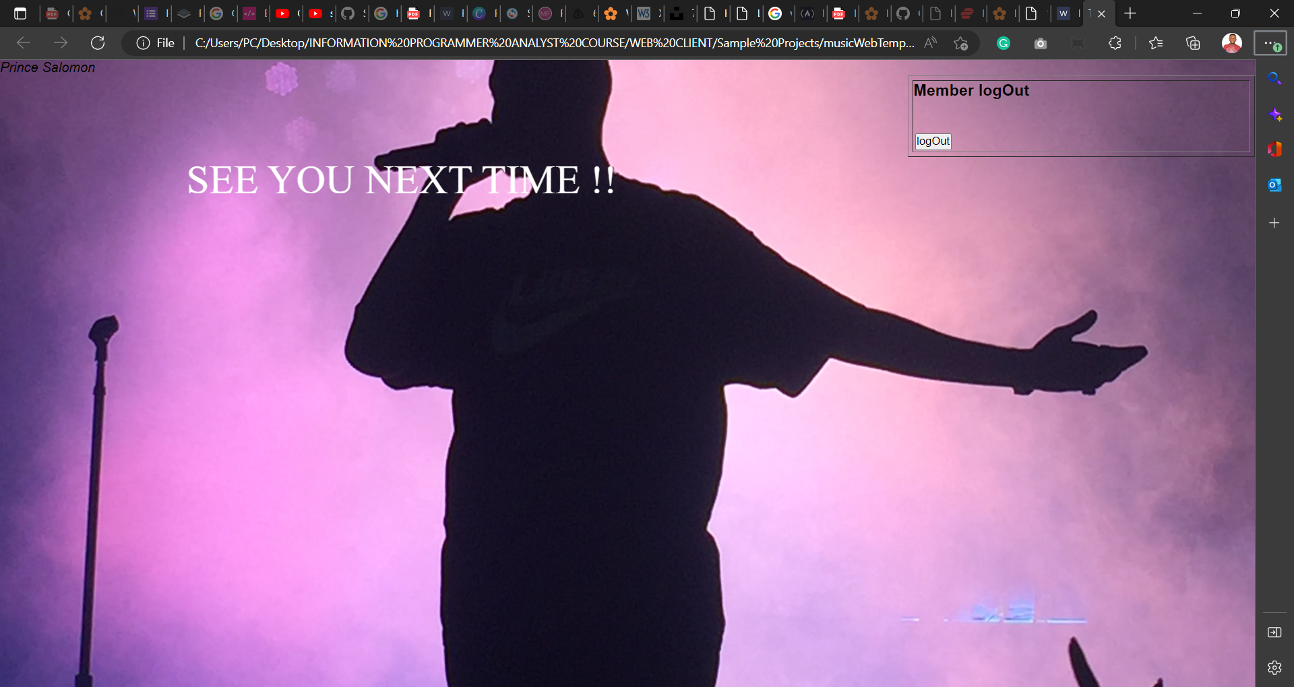

Logout page

This is my Logout page which displays when the user wants to quit the website and close the current window